# Launchpad Dashboard - UI/UX Feedback and Adjustments

## Left Menu Navigation

- Rocket Icon: Hyperlink to homepage is unnecessary; should be a static image.

- Dashboard & Annual Meeting: Both redirecting to the same screen, which is expected.

- Milestone Navigation: Clicking on milestones opens links in a new tab.

- Hover Effect on Left Menu: Green highlight should move slightly left to avoid the text being too close to the edge.

- Footer Navigation: Redirects to aos.org in a new tab.

## UI/UX Feedback

### Left Navigation Panel

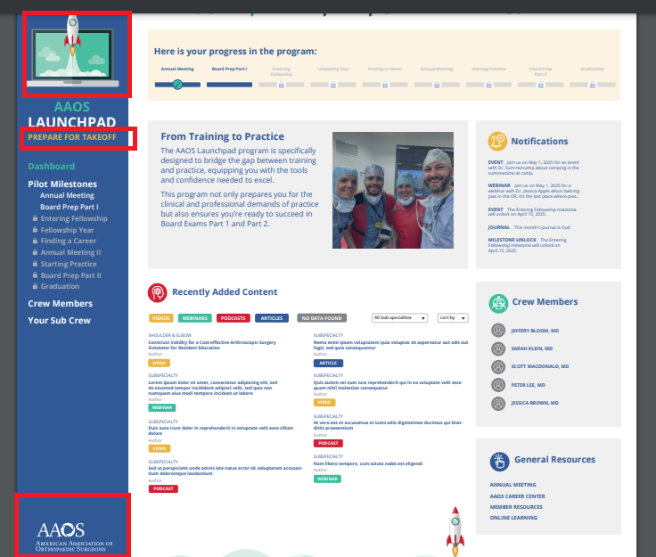

- Rocket Icon: Needs to be bigger.

- AOS Launchpad Text: 'Prepare for Takeoff' should be smaller than 'AOS Launchpad.'

- AOS Logo Placement: Should be centered in the blue box and resized.

### Milestones & Stepper

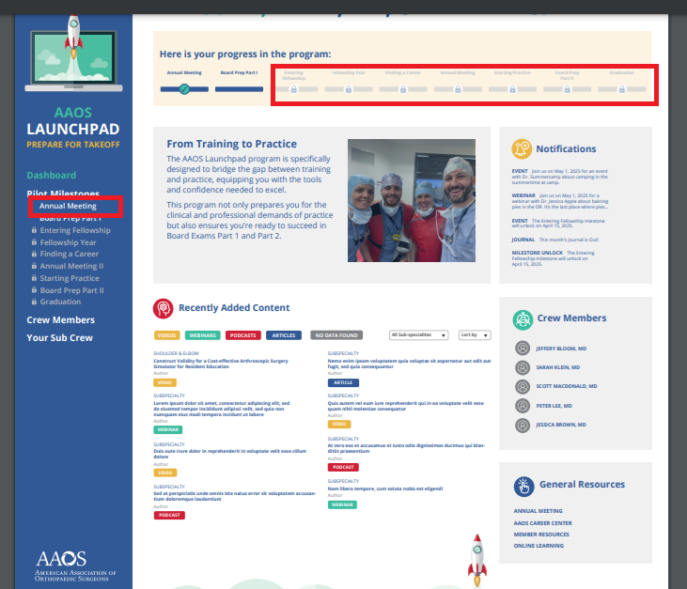

- Locks Size: Should be reduced.

- Milestone Text Spacing: Needs more padding and fainter locked milestones.

- Annual Meeting Naming: If there is 'Annual Meeting 2,' 'Annual Meeting 1' should also be labeled.

### Capitalizing

- Meeting needs Capital ‘M’.

- Font weight should be slightly thinner but adaptable for responsiveness.

### Padding Adjustments

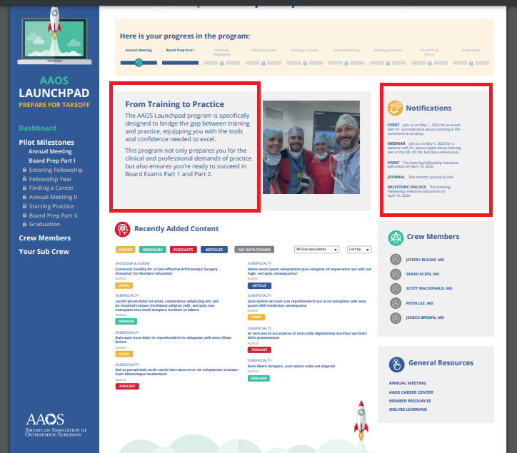

- Increase padding for Training to Practice block.

- Increase padding for Notifications block.

## Responsiveness

- Standard resolutions: Desktop (1920x1080), Mobile (360x640).

- Adjustment required for smaller screens to avoid text cramping.

- Hover effect on Left Nav: Need more spacing for better readability.

## Sign-Out Process

- Initially, clicking on the profile icon will log out users.

- Future enhancement to include a dropdown for profile-related options.

## Content Updates for Notifications Block

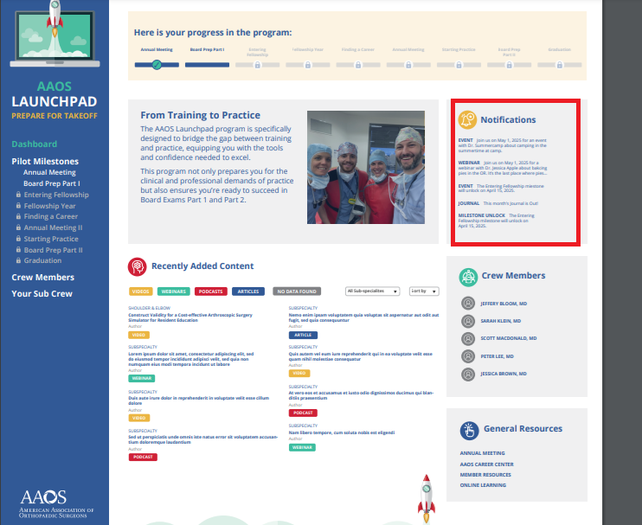

- ROCK Change to:  
'ROCK The AAOS Resident Orthopaedic Core Knowledge (ROCK) online learning platform establishes a core knowledge baseline required for orthopaedic practice and is aligned to the ABOS Part I Exam blueprint.'

- ResStudy Text Update:  
'ResStudy Access nearly 3,500 questions from AAOS self-assessment exams (SAEs) to help you prepare for the Board Certification Examination.'